**Title: Boosting chances for a Co-op with better resumes, portfolio and personal website**

Nirmayee Dighe, a Fall 21 student of Information Systems at Northeastern University, recently shared her expertise in a speaker series focused on building better resumes, a personal website, and a portfolio to display personal projects to increase our chances of getting a co-op. This summary aims to distill the key points from her insightful discussion.

**Job Roles and their Domains:**

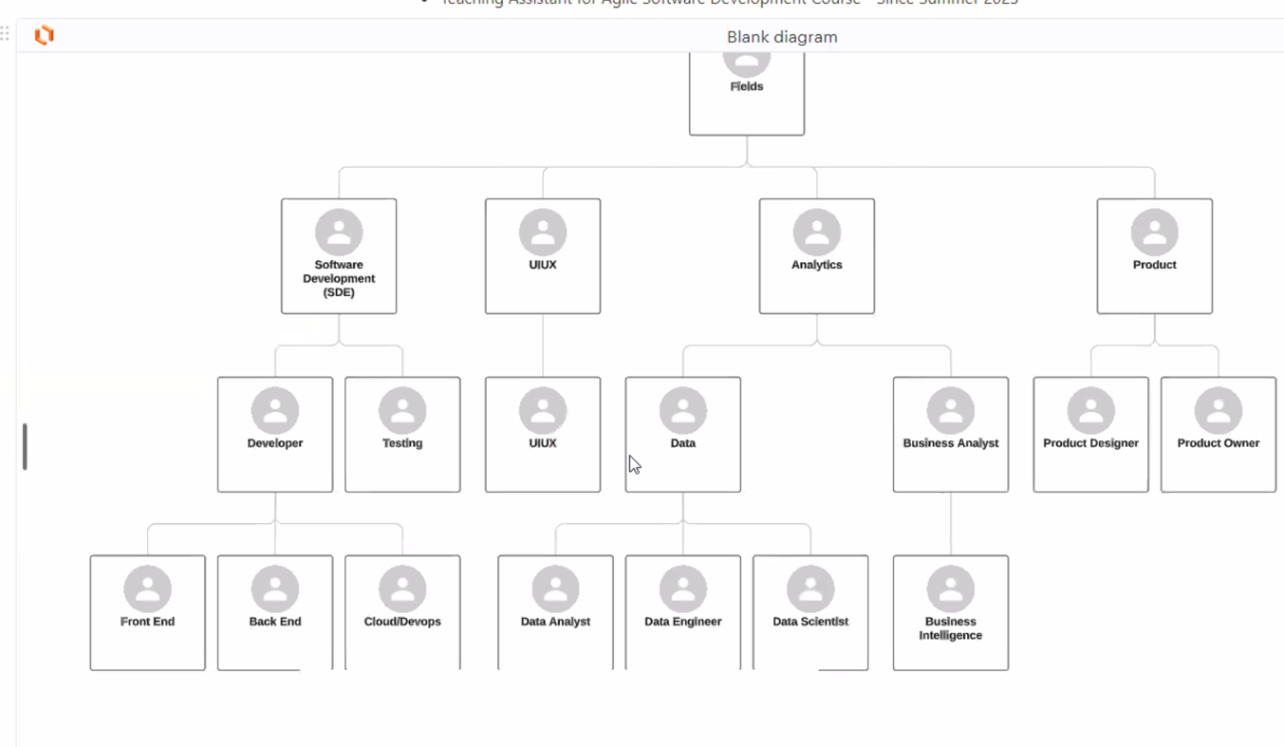

Nirmayee kicked off the speaker session by explaining to us the typical domains co-op seekers apply to and the kinds of job roles available under the domains. The key takeaway from this section was to ensure a tailored resume for each job role with the relevant skills matching the respective domain’s job description and requirements instead of a one-size-fits-all solution by keeping just one resume for all job descriptions and domains.

**Types of Resume:**

Nirmayee then delves into the two types of resumes we should have at our disposal, one for applications that might go through an ATS, and another one for in-person events.

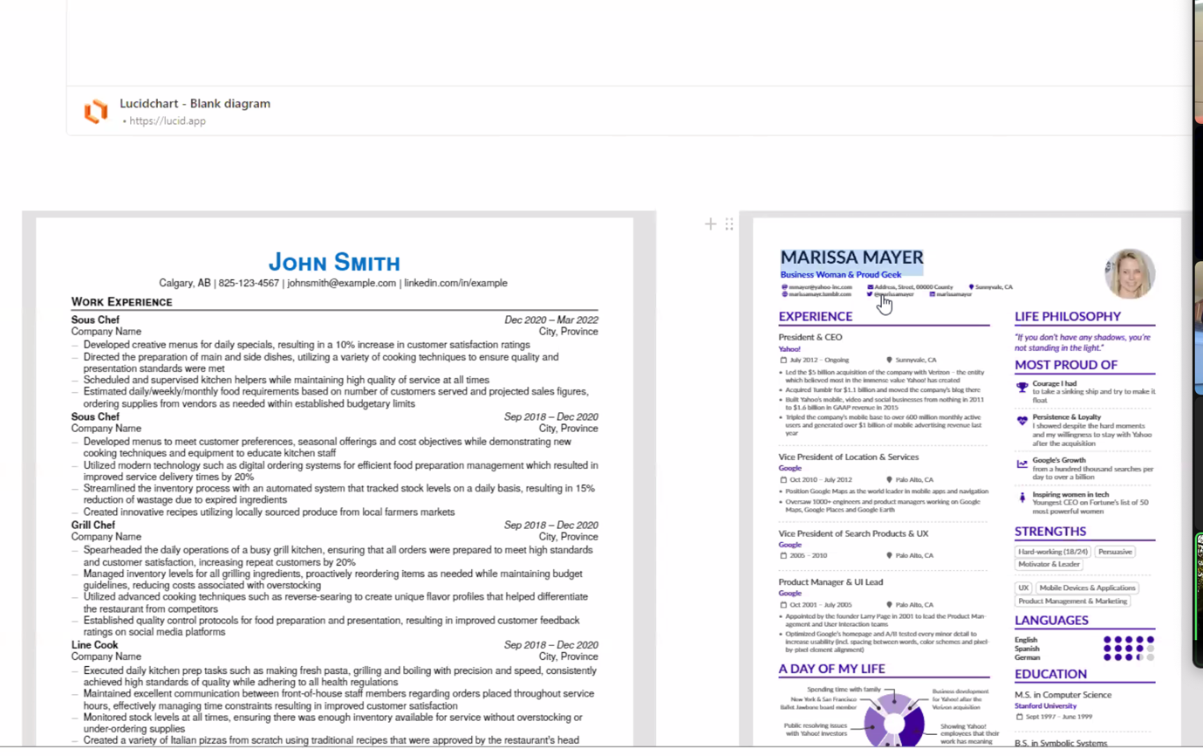

The resume on the left is for ATS scanners, to increase the probability of matches with the job description, and the resume on the right is a more personalized version of our experience. Nirmayee stressed the importance of a personalized and colorful resume that could stand out to a potential hiring manager in a networking event.

**Website Building on Wix:**

Nirmayee then demonstrates a simple way of creating a personal landing webpage on Wix. Wix is a free tool that enables students to create a personal website and creates a personal website tailored to displaying their personal and professional highlights.

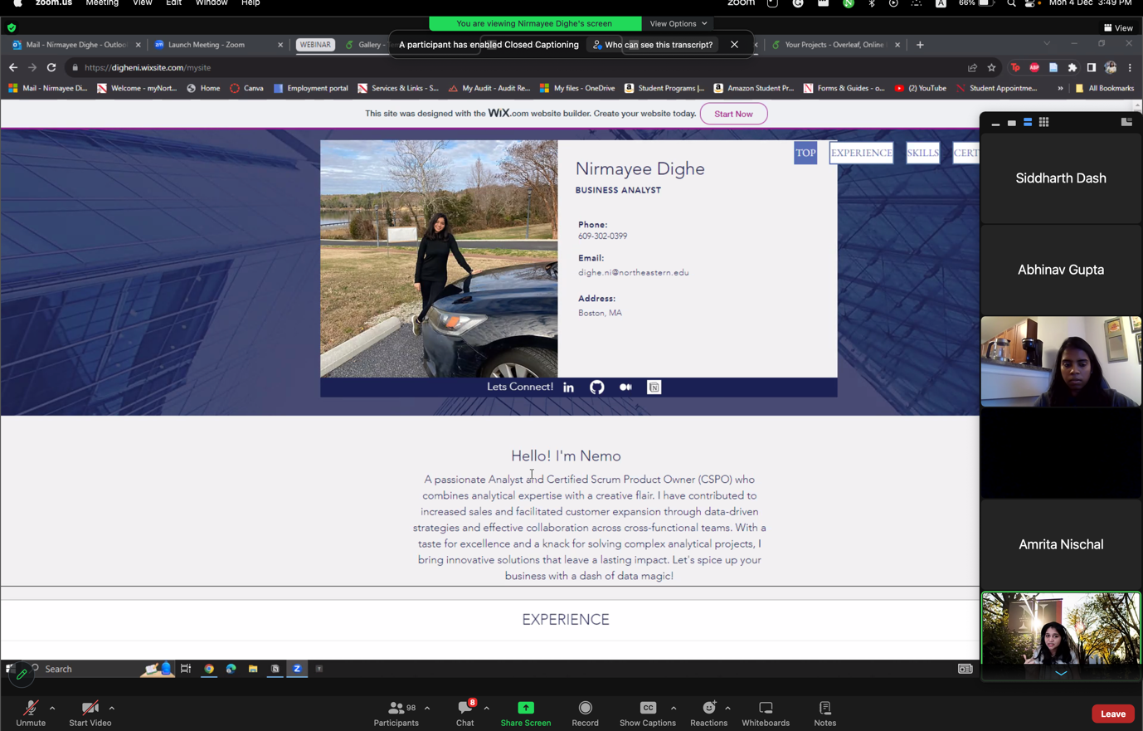

**Using Notion to Display Portfolio Projects:**

Nirmayee’s final section of the session is demonstrating the use of Notion to store our portfolio of projects. She emphasizes the need to keep our projects ready to demonstrate in the event of an interview or a meeting with a potential employer. The ability to do so gives the employer more options to know the applicant better and increases their odds of progressing in interview rounds.

In summary, Nirmayee Dighe's speaker series offers a comprehensive guide for individuals navigating the co-op search process. By focusing on tailored resumes, visually appealing personal websites, and a well-curated project portfolio, students can significantly enhance their chances of securing meaningful co-op opportunities.